October 2017
Section Officers
Chair
Greg Gdowski
Vice Chair
Dave Krispinsky
Treasurer
Bill Fowlkes
Secretary
Ray Ptucha

Chapters & Groups
AES & COMSOC
Cristiano Tapparello
CS & CIS
Bo Yuan
EDS & CSS
Sean Rommel
EMBS
Cristian Linte
GRSS
Emmett Ientilucci
LIFE
Mark Schrader
APS & MTTS
Joseph Majkowski
Photonics
Bruce Smith
PES & IAS
Jean Kendrick
SPS
Ray Ptucha
TEMS
Paul Lee
Young Professionals
Eric Brown

Student Groups
Univ. of Rochester
Tom Howard
RIT
Gill Tsouri

Committees
Awards
Jean Kendrick
Communications
Greg Gdowski
Newsletter
Anh Karam
PACE
Alex Loui

Liaisons
RES
Harold Paschal
RCSS
William Brewer
Let the celebrations begin!
3 October 2017
Report from the Chair
Sections Congress meeting in Australia – Aug 11 – 13
Ram Dhurjaty and Cristian Linte attended alongside with the delegates from Region 1. Nearly, 1,800 delegates attended the meeting. Both Ram and Cristian were able to attend many of the training sessions at Sections Congress. Young professionals, student engagement, and women in engineering affinity groups were areas of expansion that were cited as important to IEEE. The following recommendations were voted forward by delegates at Sections Congress.
- Develop an incentive program for corporations to join IEEE as ‘Corporate Member’.
- Develop (or expand existing) training programs and/or create partnerships with external organizations to allow members to provide STEM activities to pre-college students.
- Strengthen and recognize Industry/Academia/Government Collaboration/Partnerships.
More information can be found here: http://sections-congress.ieee.org

Planning for 2018: We are looking for speakers for the 2018 Engineering Symposium in Rochester, April 24, 2018 at the Riverside Convention Center, and the IEEE JCM in late March to mid-April at RIT. Contact Vice Chair, David Krispinsky (dgkite@rit.edu) for details. See you at the October Excom meeting!
Best regards,
IEEE Annual Election for 2017 – Elect officers that serve on the top-tier IEEE governing bodies. Balloting started on August 15. All ballots must be received by 1:00pm EST on October 2, 2017. Learn more about the candidates, visit: http://www.ieee.org/about/corporate/election/candidates.html
Multiple scholarships and awards are granted annually to undergraduate students affiliated with the Rochester IEEE Section.
The $1,000 scholarships recognize outstanding engineering, engineering technology, science or technology students. The application deadline is November 1st.
. Please visit the RES pages for more information: http://www.roceng.org/page-1702084.
Antennas & Propagation /Microwave Theory Techniques – Joe Majkowski
- “Quartz Precision Frequency Control Devices”, by David Chandler from Vectron International, Sept 27, 6-8pm, Timber Room, Wegmans East Ave (1750 East Ave), Rochester, NY. Buffet dinner provided! 6-6:30pm arrive, mingle, eat; 6:30-7:30pm presentation; 7:30-8pm Q&A.
You must to register to get food: https://meetings.vtools.ieee.org/m/46622.
Photonics – Bruce Smith, Parsian Mohseni
- Mariam Deutsch, NSF DMR program director and professor of physics, “Plasmonic Sensing Using Nanoscale Thin Films”, Fri, Oct 6th, 1:30pm GLE-2255.
- Professor Jung-Hun Seo, Assistant Professor, SUNY Buffalo, “Single Crystalline Semiconductor Nanomembrane-based Fast Flexible Electrics & Optoelectronics”, Fri, Nov 10th

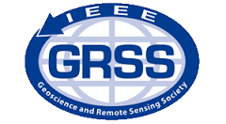
STRATUS Workshop (+ Registration), October 19th and 20th from 8am – 5pm
Location: RIT campus – Louise Slaughter Hall
Co-Sponsored by: Geoscience and Remote Sensing Society
The workshop has a 2-track submission option. You can either submit an abstract plus presentation, or a 4-page paper plus presentation. The first track is for participants who desire to share their work (abstract) during the Conference. The second track is for authors that will present a full paper to be published in the proceeding. This track requires a 4-page IEEE style paper and will undergo a full peer-review process.
The program will include both oral and poster sessions, networking breaks, exhibits, and live demonstrations.
- Early (online) registration deadline Friday, October 6, 2017
- Camera-ready paper due (full paper) Friday, October 6, 2017
Due to the generous financial support from the IEEE GRSS, early registration will be $50 ($70 late) for workshop participants. There is no cost for students to attend. Seating is limited on a first-come-first-serve basis. If you are interested in a specific tutorial(s), please complete the “Special Request” when you register.
Tutorials: (Tuesday, October 10, 2017) Each tutorial costs $20 (includes lunch)
- Tutorial 1: 9am – 12pm, “Introduction to UAV Radiometry and Reflectance” Chris Durell of Labsphere, Inc.
- Tutorial 2: 1pm – 4pm, “UAS Focused Photogrammetry / Mapping with Pix4D” Paul Spaur of Pix4D, Inc.
For details and registration, visit: http://sites.ieee.org/rochester/event/2017-stratus-workshop-registration/

41st IEEE EDS Activities in Western New York Conference – Friday, November 10 from 8:30am to 5:00pm Location: University Gallery & Web Auditorium, James E. Booth Hall, RIT
The focus of this conference is to bring engineers and researchers together to share information on a wide variety of topics related to microelectronic devices and systems. The conference will be a joint event technically co-sponsored by the Electron Devices Society and the Photonics Society of the IEEE Rochester Chapter. The conference will be held at RIT in Booth Hall; please visit the following link: http://facilities.rit.edu/campus/maps/. Lunch will be served to those that pre-register on our website: http://www.rit.edu/kgcoe/microelectronic/EDSWNY
Call for Posters: Abstracts are being solicited for poster presentations in microelectronics and photonics, especially those which promote research and development activity in Western New York. Abstracts must be received by Nov 3rd. Submission can be done electronically to kdhemc@rit.edu .
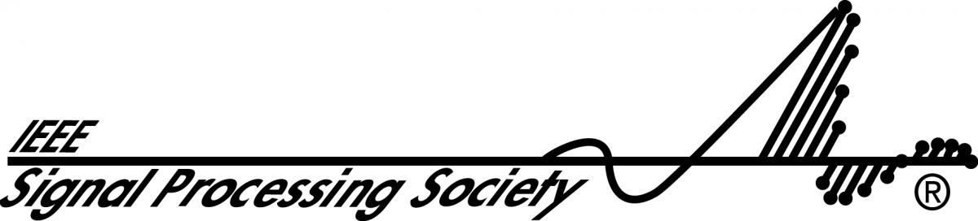
2017 Western New York Image and Signal Processing Workshop November 17 from 8:30 am to 5:30 pm @ RIT – SLA bldg. 078
Co-sponsor by: Signal Processing Society
The 20th annual Western New York Image and Signal Processing Workshop (WNYISPW) is a venue for promoting image and signal processing research in our area and for facilitating interaction between academic researchers, industry researchers, and students. The workshop comprises both oral and poster presentations.
Visit http://events.vtools.ieee.org/m/46812 for details.

NEXT Rochester Section EXCOM Meeting – October 3rd, 2017 @ 11:45 - 13:00
Location: Jade Garden Buffet in South Town Plaza 3333 W. Henrietta Rd, Henrietta, New York. Please visit our website to see more upcoming events! https://events.vtools.ieee.org/m/44006

