REGION 1 BoG MEETING MINUTES
Hilton Gardens, Mystic, CT
August 6, 2016

ADMINISTRATIVE
A1 Call to Order - Tabroff
Meeting called to order at 8:06 am.
Roll Call - Carakatsane
Sign-in Sheet, Attachment A.
Ron_T introduced the guess he invited to the meeting -
Barry Shoop, IEEE President 2016
Peter Eckstein, IEEE USA President 2016
Candidates for IEEE President, Wanda Reder and Jim Jefferies
Candidates for IEEE USA President-Elect, Ed Perkins, Charles Rubenstein and Candy Robinson
Ralph Wyndrum, Past IEEE USA President
Adrienne Hahn Staff Membership Development Regions 1 - 9
Per Bylaws Quorum present – half of the Committee and half of the Area Chairs
A2 Approval of Agenda - Tabroff
No additions or deletions.
Agenda, Attachment B.
Motion to approve: Kevin_F Seconded: Harold_B Vote: Passed
6:20 PM Executive Session
The meeting was moved into ExCom Session at this point to hear the Awards and Recognitions Committee Report. The meeting was resumed upon exiting the ExCom Session.
6:58 PM Executive Session Adjourned, Meeting resumes in open session.
A3 Director’s Report - Tabroff
Ron welcomes all the members and thanked them for attending the meeting.
Ron challenged the members to make the most of today’s meeting with the following charges.
What to expect today -
- Learning
- Deliberate
- Strategize
Will it be useful –
- To Yourself
- To Your Membership
- To the General Public
- To Industry
What role can the Region Play
- Act as Consultant
- Act as Information Conduit from IEEE
- Act as an Ombudsman to all IEEE Regional Sections
Ron encouraged the members to Network during the meeting. Section Chair should talk with fellow Section Chairs and exchange ideas for Section activities.
Next ExCom Meeting will be in Jun of 2017. A location hasn’t been determined at this time.
A4 Director-Elect’s Remarks - Beheshti
Babak_ B gave brief remarks.
He encouraged members to keep a constant line of communication with the Sections. Area Chairs are conducts to Sections and the Regional Committee is set-up to use them to communicate with the Sections. He appeals to Sections Chairs to keep a line of communications with Area Chairs.
A5 Past Director’s Remarks - Socci
Vince_S presented a report. Report included in Report Director, “Socci R1 PD Report – 1608”
Vince has four points to leave with the committee.
- Responsibility - Be informed about the IEEE Constitutional amendment.
- Growth – Make nomination for MGA committees.
- Recognition – Recommend Regional members with IEEE awards.
- Development – How do you develop yourself for the future? Take advantage of training.
A6 Secretary’s Report / Approval of Last Meetings Minutes - Carakatsane
Approval of Dec 12, 2015 ExCom Minutes, presented for Charles_R
No Amendments.
Motion to approve: Vince_S Seconded: Babal_B Vote: Passed
Approval of the March 11, 2016 ExCom Minutes
No amendments,
Motion to approve: Ralph_W Seconded: Vince_S Vote: Passed
A7 Treasurer’s Report - Prasanna
Bala presented a report on activities.
He requested that everyone submit their expense report with 3 weeks for this meeting.
Bala stressed that all Sections should complete an audit once a year. If you have an audit process continue with it if not develop a process.
He noted that our net worth has increased but membership is decreasing which will reduce future Region rebates.
Kevin Flavin questioned the level of reserve funds. Vince_S said the suggested level of reserves for the Region is > $200K based on our activities. He notes that the reserve numbers are higher as we have been setting aside $12K the last two years for Sections Congress funding.

B1 Membership Development – Wan
Soon presented two reports on activities. The report are included in the Report Director, “Region 1 MD 080616” & “MD Report – June2016 – Region 1”.
A discussion insured on what Sections are doing to increase membership.
Ron Geiger, Mid-Husdon Chair reviewed their activities.
Greg Gdowski, Rochester Chair explained that they placed an Ad in the Rochester Engineer but it cost money.
Donald McPherson, Syracuse Chair found that explaining the benefits of membership to prospective members worked.
Joseph Ott, Buffalo Chair suggested that a soft sell worked best and to check with employers if they will pay for membership. He is finding many will pay.
Kevin Flavin, Boston Chair asked Soon to send out a membership survey. Soon agreed to do it.
Adrienne Hahn, MGA Staff reviewed IEEE Day and tools and resources available to strengthen membership.
B2 PACE - Cuker
Joe presented a report on activities.
PACE Projects, budgeted $10K to award for qualifying projects. 7 of the 22 Sections have submitted projects. Money is still available to support additional projects.
Attended Future Leader’s Forum in July.
In response to a question by Greg_G, Joe to explain the approval process for project funding and how long it takes. He also offered to fast track project approvals if needed.
B3 Strategic Planning - Winston
Not present.
B4 Student Activities - Rubenstein
Charles presented a report on activities.
B5 Women In Engineering - Griffin
Denise presented a report on activities.
B6 Young Professionals - Yousuf
Aisha presented a report on activities.
B7 2017 Budget Report - Socci
Vince presented the 2017 draft budget noting it was sent out on July 17th, 28 day prior to this meeting as required by the Bylaws. Draft Budget included in Report Director, 2017-R1 Draft Budget Template V9”.
Kevin Flavin, Boston Section, request a column be added to the report showing the difference between budgeted amounts and actuals.
Motion to approve the Budget: Vince_S Seconded: Not required (motion by Committee)
Vote: Passed Unanimously
B8 Audit Report - Ruchelman
Harold presented the Audit Committee’s report. Report included in Report Director, “Audit Report”.

C1 Bylaws - Mazzola
Sandy presented two reports on activities. Report included in Report Director, “Bylaws, Operations & Leadership Training Report” & “Bylaws, Ops & Leadership Training Presentation”.
C2 Chapters - Perkins
Tom presented a report on activities. Report included in Report Director, “Chapters Coordinator Report”.
C3 Conference Coordinator - Rubenstein
Charles presented a report on activities.
Sections Congress is August 11-13th in Australia.
C4 Educational Activities - Panetta
Karen presented a report on activities. Report included in Report Director, “Educational Activities Report”.
C5 Employment & Career Activities - Wijngaarden
Adriaan presented a report on activities.
C6 Government Activities - Blackstone
Scott was not able to attend. No report.
C7 History & Milestones - Cooke
Gil reviewed the Milestone process and encouraged each Section to have a Milestone Coordinator. Believes it’s worthwhile for Sections to recognize historic sites. He offered his services to help Sections nominate Milestones.
Ralph_W says New Jersey Coast Section has 10 possible sites but requires funding to nominate them. He asks if funding is available. Gil suggest he look into industry sponsorship.
Ad Hoc Committees
C8 Information Management - Gdowski
Greg presented a report on activities.
C9 Industrial Relations - Isaak
Jim presented a report on activities.
C10 Life Members - Luceri
Louis was not able to attend. No report.
C11 Newsletter Editor - Dutta-Roy
Amitavi presented a report on activities.
C12 Pre-University Activities - Nelson
Larry was not able to attend. Larry submitted a written report. The report is included in Report Director, “K-12 Stem Literacy Report”.
C13 Section Partnership Coordinator - Socci
Vince presented a report on activities.
Vince encouraged members going to Sections Congress to be committed. It should be a learning experience which they can take back to their Sections and use.

C14 Student Professional Awareness - Hecht
Bruce presented a report on activities.
He reported that the Conference name will be a change from Student Professional Awareness Conference to Student Professional Awareness Experience.
C15 Student Representative - Ho
Kayla reported on MGA SAC F2F Meeting. Report included in Report Director, “Report on MGA SAC F2F Meeting”.
C16 Vitality Coordinator - Pellegrino
Bob reported that he sees his job as helping Sections. Bob reviewed the proper procedure to nominate and elect Section Offices.
C17 Admissions & Advancement - Mazzola
Sandy presented two reports on activities. The reports are included in the Report Director, “A & A Presentation 2016 R1 BOG Aug6 Sandy Mazzola” & “Admissions & Advancement Report”
C18 Public Visibility - Blair
Charlotte report on activities. Report included in Report Director, “160805_IEEER1BOG_PV_cblair”.
She did not present the report but instead used her time to encourage Section and Committees to reach out to the public. Publicize meetings and activities.
Section Reports
D1 Boston - Flavin
Kevin’s is included in the Report Directory, “Boston Section”.
Top Priorities –
Get non-member technologist involved.
Increase engagement
Increase communications
Increase conferences
D2 Maine - Brown
Ron’s reviewed Section activities. Report included in Report Directory, “Maine Section Report”.
Top Prior –
Increase member involvement
D3 New Hampshire - Nelson
Ed’s report is included in the Report Directory, “New Hampshire Section”.
Top Priorities –
Increase visibility
Reach out to the community.

D4 Providence - Clark
Cathy’s report is included in the report included in Report Directory, “Providence Section Report”.
Top three priorities –
Continue to growth of Chapters
Engage Student Branches
Reach out to Industry
D5 Worcester Country - Gaw
Vern’s report is included in the Report Directory, “Worcester Report”.
Top priorities –
Invigorate Student Activities
Increase Senior Member elevations
D6 Berkshire - McVeigh
James’s report is included in the Report Directory, “Berkshire Section Report”.
Top priorities –
Work with pre-college STEM
Professional Engineering licenses
D7 Green Mountain - Bates
Jason’s report is included in the Report Directory, “Green Mountain Section Report”.
Top priorities –
Make sure Section operating procedures are working properly
Increase number of meeting
Develop Web Page
D8 Mid-Hudson - Geiger
Ron’s reported.
Top priorities –
Increase personal value to members
Increase Student Branch Activates
Increase value to professional members
D9 Mohawk Valley - Cammarere
Renee present his report, Report included in the Report Directory, “Mohawk Valley Section”.
D10 Schenectady -
James’s report is report included in the Report Directory, “Schenectady Section Report”.
Top priorities –
Repair disconnect between Section and Student Branches.
Increase number of technical tours

D11 Springfield - Magotra
Neeraj’s reported.
Top priorities –
Organize interesting meetings
Power Engineering
PACE Activities
D12 Binghamton - Musuneggi
Not present.
D13 Buffalo - Ott
Joe’s report is included in the Report Directory, “Buffalo Section”.
Top priorities –
Increase Student Activities
Increase Senior Member Upgrades
D14 Rochester - Gdowski
Greg presented his report.
D15 Syracuse - McPherson
Donald’s report is included in the Report Directory, “Syracuse Section Report”.
Top priorities –
Increase Technical Activates
Rebuild Sections Communications Society membership
D16 Ithaca - Specker
Alex’s was not present but submitted a written report. Report is included in the Report Directory, “Ithaca Section Report”.
D17 Connecticut - Blair
Charlotte’s report is included in the Report Directory, “CT Section Report”
Top priorities –
Encourage Fellows to mentor younger members
Increase mid-level member involvement
Engage Student members
D18 Long Island - Islam
Sandy Mazzola reported for the Section Chair. Report included in Report Director, “Long Island Report”.
Top priorities –
Improve Website
Engage Student Members
Increase industrial involvement

D19 New Jersey Coast - Wilson
Top priorities –
Train Volunteers - Document how activates work
Make activities self-sustaining
Investigate weakness
D20 New York - Milian
Wilson’s report is included in the Report Directory, “New York Section Report”.
New York Section Priorities:

- Grow membership
Partner with major companies with large engineering staffs.
Start with known companies Con Edison and MTA NYCT

- Focus on Young professionals and Student activities:
Dr. Cathy Chen new YP chair for 2016
Active engagement of student leaders
Increase Section resources and support to effort.

- Pursue outside partnerships and joint sections activities:
a. NY Section joint support of LI Section Computer Society Conference. The 2016 New York Scientific Data Summit (NYSDS) in September.
b. Partner with IEEE History center and Intrepid Air & Space Museum to secure grant funding for new Exhibit in 2017 and will provide support for IEEE Technical forum or conference and benefit for all IEEE members in USA.
D21 North Jersey – Wijngaarden
Adriaan presented a reported.
Top priority.
Student Activities
D22 Princeton / Central New Jersey - Soll
David’s report is included in the Report Directory, “Princeton Central New Jersey Report”.
E1 New Business
No new business items were offered.
F1 Old Business
No old business items were offered.
G2 Green Mountain Section Ad Hoc Report
Babak_B reported on the Green Mountain Section Ad Hoc Committees Report and the motion approved by the Excom.
12:23 AM Adjournment
Motion to Adjourn: Charles_R Vote: Passed

Attachment A

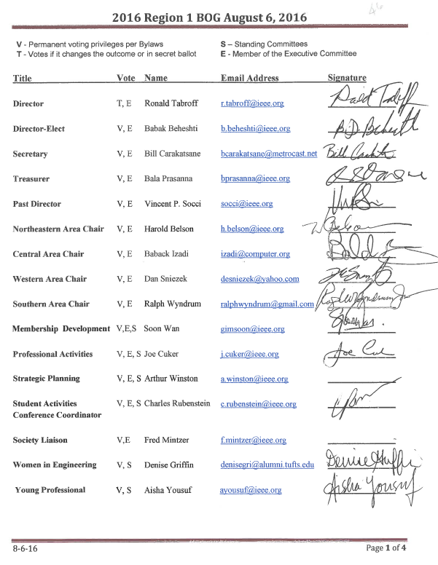

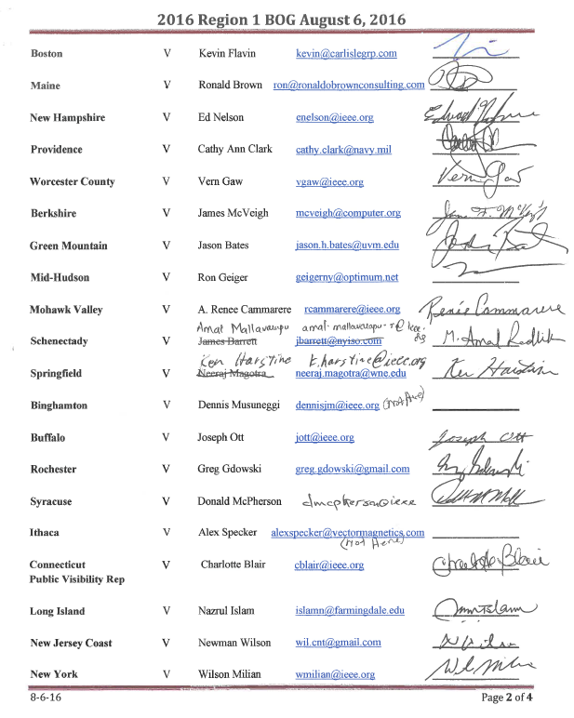
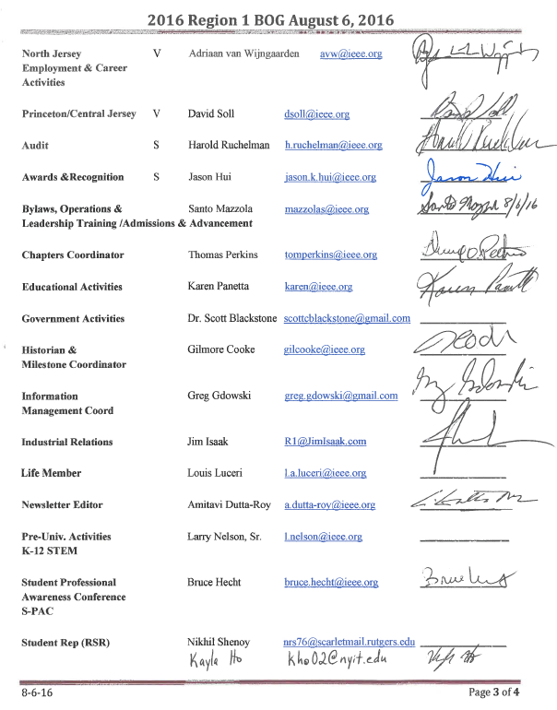

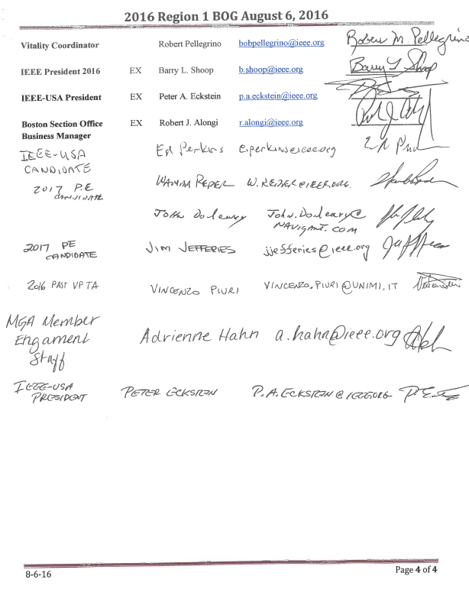

Attachment B

