To: IEEE Region 1 Board of Governor’s Meeting – August 6, 2016

From: A. Renee Cammarere, Mohawk Valley Section Chair

Subject: Region 1 Report of Goals and Activities for 2016

Activities and Goals for 2016
Geocode R10021 (Mohawk Valley Section)

Officers:
Chair – Renee Cammarere
Vice Chair – Dr. Mark Linderman
Secretary – Peter Mozloom
Treasurer – Dr. Lauren Huie Seversky – (Gave birth to a beautiful baby girl this year)
Membership Development – Jerry Genello
Goals:

To Revitalize Technical Society Chapters:
- Aerospace Electronics Systems (AES-10) Lauren Huie seversky – Chapter Chair
  - Has 2 technical luncheons in the planning stages for this year
- Communications (COM 19):
  - Greg Hadynski – Chapter Chair
  - Brian Spink – Chapter Vice-Chair
  - Held a luncheon of "Open Access Research Testbed for Next-Generation Wireless Networks" earlier this year
- Computer (C-16) – Lee Seversky – new Chapter Chair
- EMC/Reliability – Irina Kasperovich – Chapter Chair – joined with other
- IEEE Systems Council Chapter – Robert Riley - We are currently in the process of petitioning for the formation of this, and have all of the signatures we need now - http://ieeesystemscouncil.org/content/member-societies .
- Signal Processing (SP) - John Matyjas – Chapter Chair – John has been actively involved in all events that we took part in this year.
In Summary: We have met our goal by keeping these going and have been encouraging Chairs to schedule events for society members. We are also in the process of finally submitting the petition for the formation of a Systems Council, which we believe would get a good response from members.

To Fund Awards:

- Charles Strom Awards to recognize high school students performing exceptionally well in Math and Science - Jerry Genello and Jerry Capraro were in charge of selection - We decided on 5 awards at $400 each
- MVEEC/MVIEEE Recognition Award – We also recognized Dr. Misty Blowers and Dr. Bryant Wysocki for the work that they did with the IEEE CISDA Conference last year at the Turning Stone Casino with plaques.
- Awards Banquet - We participated in the 65th Annual Mohawk Valley Technical Awards banquet, which happened on April 21st at the Beeches in Rome, NY, during which time we presented the above mentioned awards. We also had an exhibition table set up at this banquet
In Summary: We were able to fund the STROM Awards again this year, which was our main goal.

To Revitalize Interest in IEEE within our Technical Community:

- Co-sponsorship with Erie Canal AFCEA Chapter 2016 C4I and Cyber Conference (June 13th through the 16th) - (http://www.griffissinstitute.org/about-us/events/ev-detail/afcea-erie-canal-chapter-6th-biennial-c4i-and-cyber-conference) – We were one of the exhibitors during the entire conference, and conducted a membership drive at the conference, which took place at the Radisson Hotel in Utica, NY. 300 copies of an MV IEEE flyer, (put together by our secretary) were placed in the notebooks that were given out to all attendees.

To Donate to Local Educational Events:

- MATHCounts – Held on 2/6/2016 at Mohawk Valley Community College in Utica -We donated $350.00 as well as participation in the event by a few members

- Project SITES – Held on 3/24/2016 at Hart’s Hill Inn in Utica - We donated $350.00 as well as participation in the event by a few members

- Utica College Regional Science Fair which took place on April 2, 2016 – We participated by judging one 16 – 18 year old student to receive an IEEE Engineering and Computer Science award. It was a medal with engraving, a framed certificate and a check for $100. Several of our members judged other awards as well.

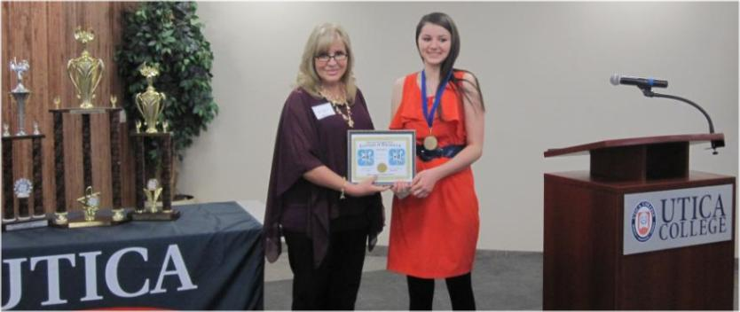
Picture and article regarding MV IEEE involvement was published in local paper

- ANDRO’s 2016 Project Fibonacci STEAM Youth Conference August 1st through the 5th of this year –Andrew Drozd, President and Chief Scientist at ANDRO Computational Solutions, presented The Fibonacci project (http://www.projectfibonacci.org/) to us at the December 2015Executive Committee meeting and as a result we became a Bronze Sponsor and will be exhibiting for IEEE and operating a membership drive there. (Due to the celebrity guests to appear there, we should get good exposure to the public.)

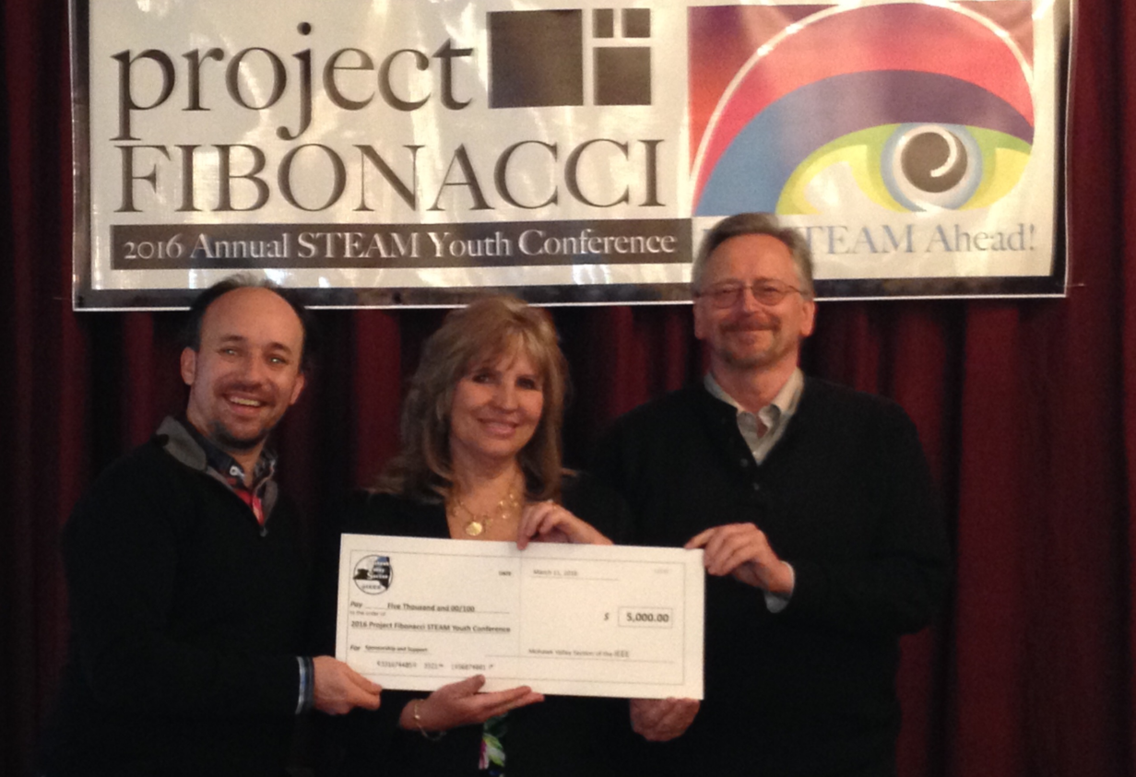
Picture and article regarding MV IEEE involvement was published in local paper

To Get a Project going for PACE:

- Drone Project - We have Gerry Genello as PACE coordinator, who is working hard on the drone activity for middle school and high school age students this year. We have the funding that we need, as well as the approval from MV IEEE members. Several local schools, as well as The Griffiss Institute in Rome are rendering services for this effort as well.

To Revitalize College Students participation in IEEE:

- SUNY Polytechnic Institute - We currently have a group of 30 or so students from SUNY Polytechnic Institute in Utica, having formed an IEEE club. (They were represented at our IEEE Day event last year.) Jerry Genello and I are getting them involved with local IEEE events this year as well.
- Clarkson University - We are planning an IEEE event at Clarkson University for October of this year. One of their professors, Dr. Chen Liu is assisting us with that, and has a fair amount of IEEE student membership represented there.

Respectfully submitted,

A. Renee Cammarere
Institute of Electrical and Electronics Engineers (IEEE)
Region 1, Mohawk Valley Section Chair
https://www.ieee.org/go/mohawkvalley

