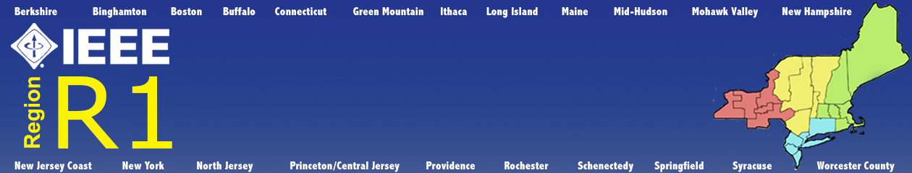

EXCOM MEETING MINUTES
MARCH 23, 2018
MIRAJ HEALTHY GRILL
WILLISTON PARK, NY

A ADMINISTRATIVE
A1 Call to Order
The meeting was called to order by Director Beheshti at 9:01 P.M.
A2 Roll Call
All ExCom members were present except Soon Wan.
A3 Approval of Agenda
The Agenda was approved unanimously.
A4 Director’s Remarks
Training
Training of Section officers was held via 2 webinar sessions. The summary results were good. The attendees want more sessions and more time. The Region can deliver service via our platform at nearly zero cost. Director Beheshti thanked all involved with the setup and delivery of the program.
Section Actiivities
Director Beheshti noted that the Sections have been active in forming affinity groups and technical chapters. He asked the Area Chairs to work with their Sections to help keep them active.
Summer Meeting
The meeting will be held on August 10 -12 in White Plains NY. The contract is presently being negotiated. The Director said the he wants to focus on the agenda items, not just reports.
IEEE and IEEE-USA Candidates will be invited to address the BoG
On Sunday, from 8 or 9 to Noon, four training tracks are being planned.
The Director said that he ahs been unable to reach all ExCom members to set priorities.
Director Beheshti wants to create position descriptions for all ExCom positions.
A5 Director-Elect’s Remarks
Director-Elect Palacio said that he wants to focus on issues that need resolution and under represented groups in IEEE (YP, WIE) – What do the need and/or want?
A6 Past Director’s Remarks
Past Director Tabroff noted that 2018 was the first year that member retention was positive. He would like to see that continue.
A7 Secretary’s Report
No Report
A8 Approval of Minutes of Last Meeting
Secretary Eckstein reported that as he was not the Secretary at the time of the last meeting, he did not have the minites. He would attempt to get the minutes from the prior secretary.
A9 Treasurer’s Report
Director Beheshti thanked Treasurer Prasanna for his efforts on behalf of the Region.
Treasurer Prasanna reported that the $50,000 borrowed for LTIF in 2012 con now be replenished, ($50,000 - $80,000 to cover principle and interest. Ron Tabroff will work with Treasurer Prasanna to determine the actual amount. They will confer with IEEE staff to determine the repayment schedule.
The Treasurer presented the audit report from Audit Chair Ruchelman. He added that all Sections should perform their own by the August meeting.
Director Beheshti asked Past Chair Tabroff to work with the Treasurer to develop a proposed 2019 budget for the August meeting.
A10 Call for Director Elect Nominations Process
Director Beheshti asked Past Director Tabroff to form a committee to generate a list of at least two to a maximum of three nominees for Director Elect. That list will be presented to the Region Assembly for them to select candidates. He stressed that the timing of that N&A Committee’s is critical so that petition candidates may be developed.
A11 Bylaw Change Regarding Area Chair Election
Director Beheshti began the discussion by history of the selection process in Region 1. In the past the Area Chairs were appointed by the Director, as is done in all other Regions. That was changed to more evenly balance appointed and elected members of the BoG.
A motion to modify the wording of the motion was made, but failed.
A motion was made to accept the proposed modification to the Bylaws and passed by a vote of 7 to 4 with one abstention, Past Director Tabroff.
A12 Increasing Region Assessment by $2
Director Beheshti began the discussion by noting that face-to-face training as the Region used to do it at the August meeting is too expensive. However we still need an increase. More of our members are becoming Life Members and funding from IEEE-USA has decreased, (down $12,000 this year). The Assessment income has dropped from $108k in 2011 to $89.5k in 2017. We need to find ways to decrease our spending without sacrificing services.
The Director said he would appoint an ad-hoc committee consisting of Bala Prasanna, Ed Palacio and Vince Socci, to examine alternatives and to make recommendations by the end of May for further discussion.
B AREA CHAIR REPORTS
B1 Central Area Report
Chair Sniezek reported that all Central Area Sections have all required officers, but he still needs contact information for some of them.
B2 Northeastern Area Report
Chair Belson said the he would be visiting the Maine Section. He has developed a presentation based on training.
B3 Southern Area Report
Chair Wilson reported that:
- He would like to hold a webex for all Sections.
- It is hard to recruit volunteers. Some Chapters still need officers.
- He wants to get information about an Affinity Group that was deactivated. He would like to see a system in place that would provide notification before the deactivation. The section is notified ahead of time but that gets dropped if the section leadership changes.
B4 Western Area Report
Chair Gdowski provided a written report and did not make any additions

C OLD BUSINESS
C1 Student Activities Conference
SAC Coordinator Rubenstein said he would see everyone at the conference in the morning.
D NEW BUSINESS
D1 IEEE-USA Awards
Chairman Hui asked all Area Chairs to work with their Sections to develop a list of nominees. We are not generating enough candidates for Region or IEEE-USA awards. We should look at the recipients of Section Awards as a prospective pool of nominees.
Denise Griffin is working to develop a WIE award similar to SWE that is given to a person or company that promotes Women in Engineering.
D2 Priorities for 2018
This topic was postponed to a later date.
D3 Non-performing Sections
This topic was postponed to a later date
E ADJOURN
The meeting was adjourned at 10:57 P.M.

