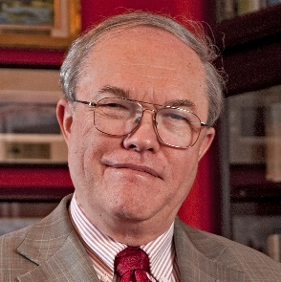
Dr. Brendan Godfrey

Candidate for IEEE-USA
2020 President-Elect, 2021 President
brendan.godfrey@ieee.org; website in development

Career in Government, Industry
- Management and research in FFRDC, small business, U.S. Air Force
- Responsible for as many as 1500 people, budgets as large as $500M
- Served on many advisory committees (National Academies, governments, universities)
- PhD – Princeton University
Active Contributor to IEEE
- IEEE-USA Volunteer
  - IEEE-USA Board, Vice-President for Government Relations
  - R&D Policy Committee Chair, Artificial Intelligence Policy Committee Chair
  - Authored several position statements; made numerous Congressional visits
- Nuclear and Plasma Sciences Society
  - AdCom (three terms)
  - Plasma Science and Applications Chair
- IEEE Life Fellow (also APS Fellow)
Why Run for IEEE-USA President?
- Focus on enhancing Government Relations
  - Important activity, opportunities for improvement, well qualified to do so
- While not ignoring Membership Development, Career Services
  - Continue current President’s initiatives, work closely with six Region Directors
Provide increasingly effective voice in Washington for IEEE-USA members
- Solid Government Relations results past four years
  - Increased federal support for S&T research
  - Federal S&Es again can attend IEEE conferences
  - Educated Congress on H-1B visa abuses
  - Permanent R&D tax credit
- Much more to be accomplished
  - Mobilize membership for advocacy; provide training
  - Address additional important issues: internet privacy, H-1B reform, cyber security, balanced export control, improved R&D tax credit, etc.
- Increase visibility, internally and externally (articles, talks, Op-Eds, etc.)
- Recruit more volunteers, esp. younger members
Effectively Represent U.S. Membership as IEEE Board Member
- Team with Region Directors to identify, advocate issues important to U.S. members
- Explore alternative membership and financial models for a changing environment
- Promote openness and transparency

