Annual Section Report 2018
New Jersey Coast Section, IEEE

NJ Coast Section Report

NJ Coast is an illustrious section with a legacy with 65 years and a vibrant community of volunteers. We have approximately 1000 members in our section with more than 100 life members. We have made significant strides in serving our area members by continuing the diverse section/chapter/ affinity group activities and adding new ones. And we have an exciting plan and a motivated team working for year 2019. Please find below a summary of activities for 2018 and a plan for 2019.

Executive Committee Meeting
The Executive Committee meets once a month except summer months. It includes the Section Officers as well as Chairs and Vice Chairs of all the chapters and committees. The meeting is also open to general members. The Committee discusses the plans of actions for the Section, approves budgets and any new or changes in the policies.

Some of the issues/topics the Executive Committee is, or will be addressing are:
- Section Leadership—Introduce new officers
- Elections - future officers
- State of the Section Summary
- Chapter Updates
- Historical Milestone Planning
- Financial Reporting and Audit Updates
- Section website
- More participation and more talks
- Getting Young Professionals involved

Section Technical Conferences
The Section is actively involved in organizing and supporting technical conferences in the region. In 2019 the Section supported the following conferences:
- 2018 ACS Symposium

Section Technical Meetings
Various Society Chapters of the Section have organized technical meetings where distinguished experts both from academia and industry give lectures on the state-of-the-art technologies and research and developments.

- For the year 2018 we had altogether 29 talks held by the following chapters / affinity groups
  - Aerospace and Electronic systems / Engineering Management chapter (0)
  - Microwave Theory & Techniques / Electron devices / Laser & Electro optics chapter (4)
  - Communication society chapter (3)
  - Antenna Propagation/Vehicular Technology/Electro Magnetic Compatibility chapter (6)
  - Computer and Instrumentation Chapter (3)
  - Consultant Network Chapter (3)
  - Life Member (2)
- A lunch event held on March 29, 2018 with speaker Russell Harrison
Title of talk: What Congress is up to, and How it will Affect Engineers
- A lunch event held on Sep. 20, 2018 with speaker John Cervini
Title of talk: : Electronic Warfare Technology
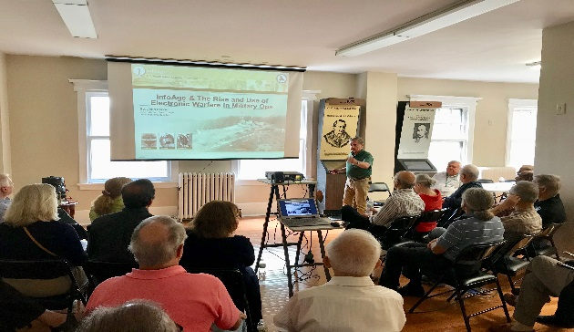

  - Power and Energy (0)
In addition, the following professional activities team also contributed additional talks:
  - Women In Engineering (5)
  - PACE (Professional Activities Committees for Engineers) (3)
The History and PACE chapters led by Dr. Katherine August has conducted the following activities:
- Published an article in the IEEE History Center Newsletter November 2018 on the ‘The Ways the New Jersey Coast Section is Bringing History Alive.’
- Planning another Milestone for Student Chapter at Stevens Institute of Technology for Neutrodyne Circuit by Professor Alan Hazeltine, 1922. Collaborating with Student Chapter Chair Matt Tomarow.
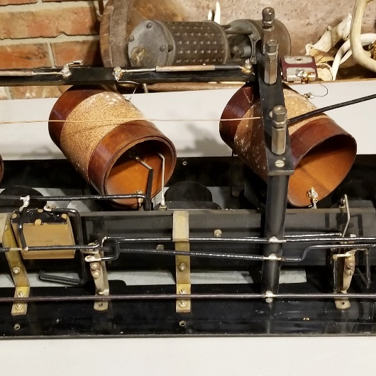
- Entered our IEEE NJ Coast Section PACE project in a Women’s History Month Humanitarian Activities Project photo contest. Represents a collaboration with a large group of people.
- 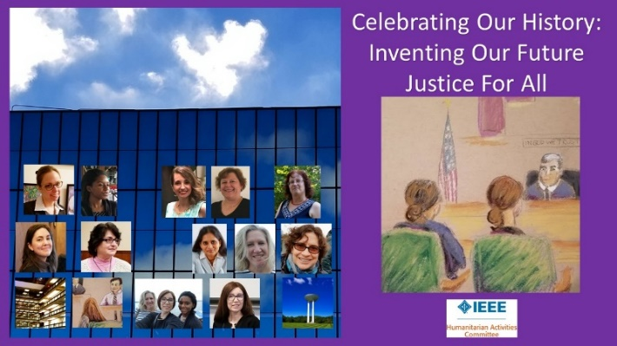
- Planned and executing a Women’s History Month Event to be held 27 March 2019 3 – 5pm at Stevens Institute of Technology Lore-El Center for Women’s Leadership to be introduced by Professor Dr Lisa Nocks of the IEEE History Center with four speakers: Dr Yingying Jennifer Chen of Rutgers, Dr Kahina Lasfer of MTA, Dr Paula Mueller of SociAvi, and LTC Professor Dr Kathryn Pegues of the United States Military Academy.
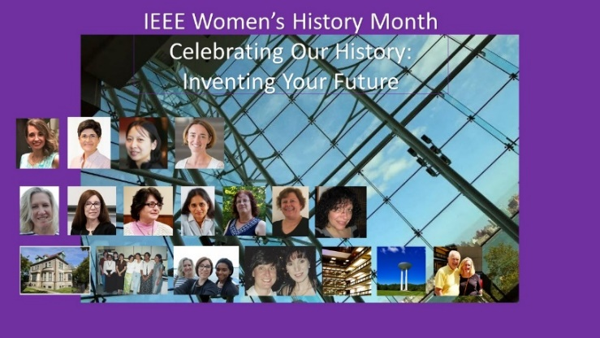

Awards and Awards Banquet
The 2018 IEEE NJ Coast Awards banquet was held jointly with IEEE Princeton/Central Jersey Section in June at the Grand Ballroom, Colts Neck Inn, Colts Neck, NJ. The Princeton/Central Jersey Section and the NJ Coast Section organize this joint event to pay tribute to the new IEEE Fellows in the Sections, and to recognize accomplishments of engineers and computer scientists with significant contributions in our area. This year we honored two IEEE Fellows in our section, three IEEE Region 1 awardees and two Section awardees across all categories, who continue their excellence in enhancing the technological development of the society.

Historical Milestone
The IEEE Board of Directors has approved the NJ Coast Section’s proposal of an historic milestone for the use of Radar Signals Reflected from the Moon, January 10, 1946 at Camp Diana, Fort Monmouth, NJ. The achievement, which demonstrated the ability to communicate with extraterrestrial bodies beyond Earth, birthed radar astronomy and began the space age, creating requirements for the evolution to solid-state, and paving the way for satellite communications. An event will be held on May 15th of 2019 to dedicate a plaque at InfoAge Museum, Wall Township, NJ.

WIE Society Chapter Mini Academy
The consistent and dedicated work of our chapter volunteers Mihaela Dinu, Margaret Lyons, Tima Shehadeh Gant resulted in the IEEE 5th annual Mini Engineering Academy sponsored by the NJ Coast taking place at Neptune High School in Neptune, NJ. There were over 50 participating high school students. Topics in the 6-week academy were Robotics, 3D printing, CleanEnergy, Smart Phone technology, breadboarding radio circuits green building design, and Pneumatic Rockets.

PACE
Summary of the proposal to fund our ICCDD project.

Engage Members from many Societies and Affinity Groups crossing domains to create a forward looking interdisciplinary Community Focused project, focused on including user groups with hearing loss, student engineers, and those with experience. In addition to Section Members, the project incorporates Stevens Institute of Technology, Gallaudet University, experts in Robotics, Biomedical Engineers, and others from fields of emerging import.
Participants will create an online presence for the project, meet with students and users, plan a hackathon, create a library of resources, repository of data, collaborate to program a robot, and engage in new engineering and business models and techniques such as open source code, building apps, machine learning, big data, cloud learning, engaging user groups, sharing results. Other projects will dovetail with this foundation project which is planned to serve the needs of the Members, prospective Members, and a Need of the Community who experience hearing loss or deafness.
Membership Enhancement
We have facilitated and promoted some members to Senior Member level in 2018.
We have recongnized for meeting the recruitment goal for the 2018 membership year.
The membership development goals were developed based on your Section’s three year performance. We have been commended for continuing to grow IEEE membership in the New Jersey Coast Sectionn.

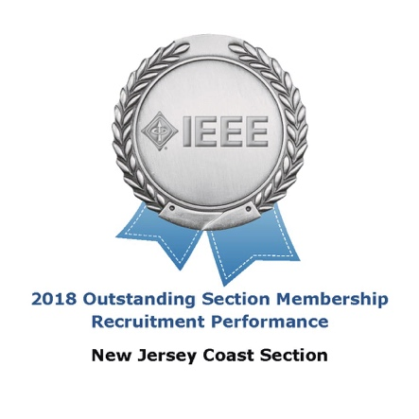
IEEE Day
To celebrate the IEEE Day and have a team building event, we are planning a trip for the members of section to Liberty Science Center Sat Oct 6, 2019.

2019 Plan
For the year 2019 about 25 talks are planned more or less on similar lines as above.

Report Prepared by Claude Martell

