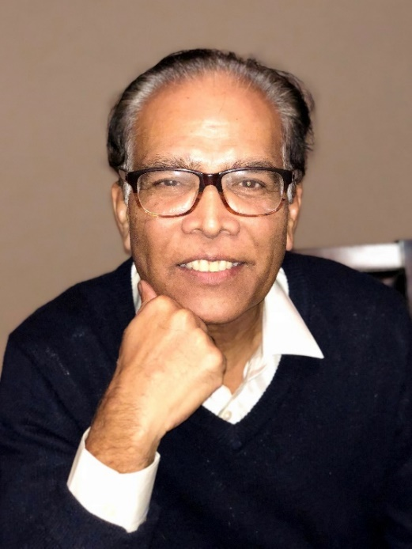
IEEE Region 1 Director–Elect, 2020-21
Candidate Name: Bala S Prasanna
IEEE Member Grade: Senior
Biography: Recently retired after a rewarding and exhilarating career of over 35 years that began with joining the workforce during the nascence of the Information Technology revolution, Bala Prasanna has architected, developed, managed and supported several multi-million-dollar mission-critical software systems. He has also taught computer science, information technology, and career-management/professional development courses at various universities. He was mentored by some of the best and brightest in the industry throughout his career as he assumed various job roles as a college professor, principal technical staff member, and senior IT manager/executive at SUNY, Bell Labs, AT&T & IBM. He was consistently ranked high among his peers for his leadership, management, analytical, and humanistic skills and a record of results.
IEEE Activities:
- IEEE- Region 1 EXCOM/BOG, Treasurer 2010-present
- IEEE FINCOM Member 2016, 2017
- IEEE-USA Board Member – Secretary/Treasurer 2016 & 2017 (reappointed)
- IEEE METSAC Vice Chair
- IEEE PACE/SPAC National Speaker – (National & International, over 70 talks)
- IEEE Region 1 SPAC Coordinator
- IEEE NJ Coast Section – Chair, Vice Chair, Secretary, Awards Chair (present)
Awards and Other Recognitions
- IEEE Third Millennium Award - 2000
- IEEE Region 1 Award
- Book Chapter and technical publications on Software Reliability Engineering
- Taught for over 12 years at Morgan State University (MD) as part of AT&T’s Diversity/Community Outreach program while working at AT&T
Statement of Willingness to Serve: Are you willing to serve as IEEE Region 1 2020-21 Director-Elect, 2022-23 Director and 2024-25 Past Director: YES

Qualifications:
I have significant insight and experience into all aspects of the Region Director, thanks particularly to my time served as Region 1 Treasurer (9 years and counting) and IEEE-USA board member (2 years). At the grassroots level, having served in various roles including chapter and section chair, I have a fundamental and unique top-down and bottom-up understanding of how things work and what needs fixing. In my private and professional life, I have held numerous technical and managerial positions where I was responsible for delivering complex systems, managing large teams, and often times being the SPOC for high-visibility incident-management situations where I was simultaneously reporting to top brass and working with hands-on technical people. I have taught extensively at the university level, and I am still answering the call for career management or soft skills development talks at domestic and international universities. The totality of my experience has taught me how to be a successful leader and manager and a good volunteer.

Major Accomplishments
As IEEE Region 1 Treasurer, I provided unblemished and accurate reporting, supported audits, provided timely service to volunteers, and led and oversaw completion of region-level compliance items by section/chapter treasurers. My approach and results have been appreciated and complimented numerous times. Having incoming region directors asking me to stay on during their term of office is an appreciation and reward that I cherish. My time spent investigating, understanding, analyzing, and putting forth a moderate resolution for the most beneficial outcome in several critical incidents/issues that affected the region have made me a person to lean on by region leaders.
As IEEE-USA Secretary/Treasurer and FINCOM member, I was hands on in learning and providing my input on financial matters from a top-down level. This was an eye-opening experience, and I am eager to apply these lessons to the position of Region Director.
In Industry and Private Life – Over the course of my career, I have grown from an entry-level worker to a manager leading large teams, building consensus, and delivering results.
I was blessed to have great mentors who took me under their wings and taught me generously. I can never overstate how they have helped me to grow and come ahead so many times in my career. Working with disparate teams, and being in the thick of high visibility incident situations have taught me well to endure and come out with heads held high for all involved.

Position Statement:
If elected, I would work closely to empower fellow volunteers in policy and practical matters to be able to deliver maximum benefits to membership, be diligent in overseeing how every dollar is received and spent, and build and broaden relationship with peer volunteer leaders and IEEE staff to bring back and implement what is best for Region 1.

