The Schenectady Section (http://sites.ieee.org/schenectady/) is focusing this year on community outreach, membership volunteering, Senior Membership promotion, and working with the local student branches to support their activities.

Membership
Our section has a total of 816 active members, of which 133 are Senior Members, and 413 are regular members. We are in the process of setting up a committee to promote and aid in Senior Member applications. The committee will consist of current Senior Members that will help review and provide recommendations for Members applying for Senior Membership status. The section will hold Senior Membership drives to inform about and promote the application process.
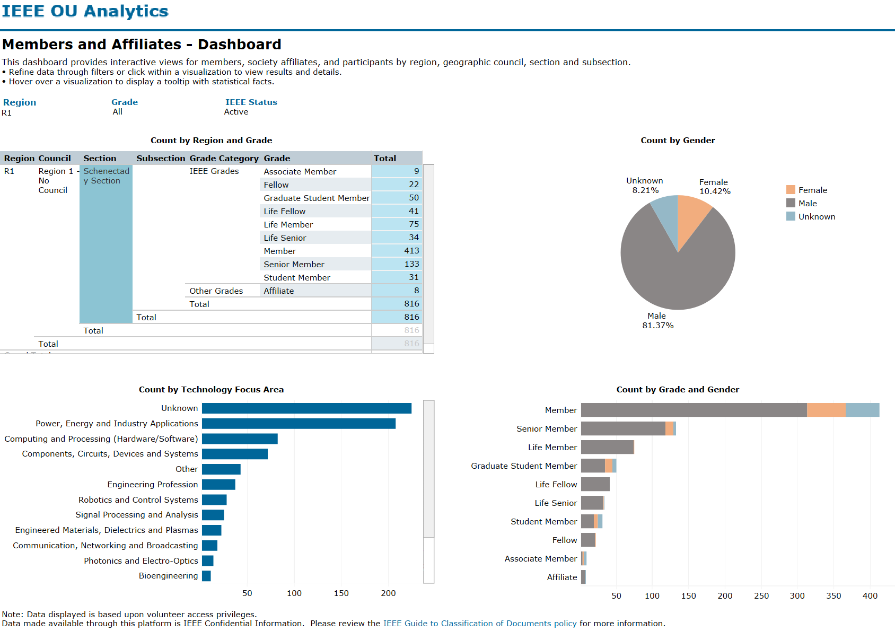

Section Organization
Our section consists of 7 active Society Chapters, 1 Affinity Group, and 4 main student branches. Approximately 60% of volunteer positions are filled, and the vacant positions are mostly Section Appointed positions. We will be actively recruiting additional volunteers to fill the vacant positions as we are able. Our main mode of recruitment has been through word of mouth, which has been highly successful. We encourage current volunteers to recruit their colleagues and connections to fill either vacant positions or to replace their positions for the following year, providing a clear path of succession.
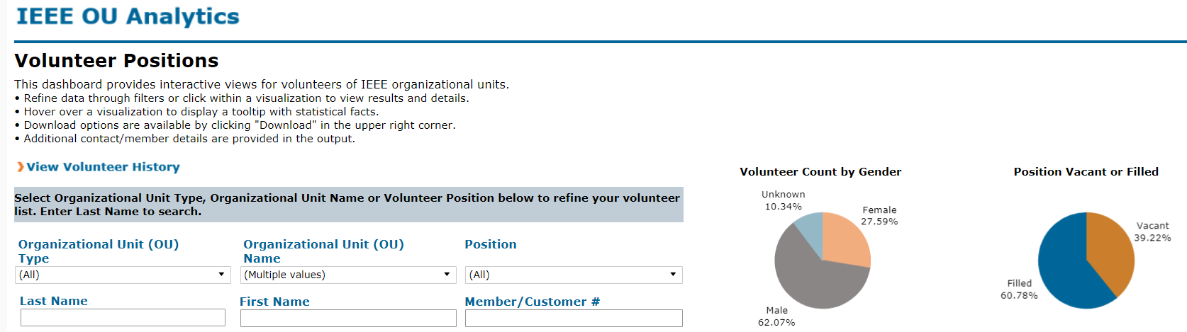
The local chapter of the Computational Intelligence Society has been revived through the efforts of a newly elected, local Senior Member who was acquainted with a previous section volunteer. The CIS chapter is actively recruiting speakers for local presentations.
Furthermore, there is an effort to recruit at least 3 more members to the Society on Social Implications of Technology (SSIT) to start a local chapter. An alternative option is forming a joint chapter with the Computer Society.
Active Chapters:
- Computational Intelligence Society (CIS)
- Computer Society (CS)
- Dielectrics and Electrical Insulation Society (DEIS)
- Electron Device Society (EDS)
- Industry Applications Society (IAS)
- Power and Energy Society (PES)
- Signal Processing Society (SPS)
Affinity Group:
- Women in Engineering (WIE)
Student Branches:
- RPI (unknown status this year)
- SUNY Albany (active)
- SUNY Polytechnic Institute (unknown status this year)
- Union College (semi-active)

Student Branches
The SUNY Albany student branch has become active starting in 2018, in conjunction with the formation of the ECE department in the newly formed engineering school. The section has reached out to the other student branches. The status and activity of RPI and SUNY Polytechnic Institute are unknown. Both of the branches had been active in the past. We find that the active level fluctuates, most likely due to particularly active students graduating without a similar level of leadership in succession. Union College is working to become more active.
Section leadership has invited student branch chairs and faculty advisors to attend the monthly ExCom meetings to promote communication and activity within the student branches.
Furthermore, the section has approved financial support limits of $750 per student branch for 2019, which will be available upon request on a per-event basis. So far, only SUNY Albany has been utilizing this support in the form of monthly student meetings and talks. We will be pushing a similar system with the other student branches to promote student activity and involvement. Lastly, we will encourage the student branches to apply for available IEEE funds for student branches in future years.

Community Outreach
A number of efforts are underway to promote increase community outreach and awareness.
Our section helped sponsor (to a level of $500) a local Future City Competition (https://futurecity.org/) held at Sage College in Albany, NY on January 12, 2019. The theme of this year was “Powering Our Future – Excellence in Energy Efficiency Applications”. Two of our section volunteers volunteered as special awards judges. Local middle school students participated with a total of 8 projects eligible for the award. The judges narrowed down the finalists to two teams that split the award.
The Computer Society is planning to implement a local hackathon to promote computer programming. Current CS leadership has prior experience implementing and running hackathons. Logistics and planning are underway.
Upcoming outreach opportunities that our section is planning to support with volunteers are Questar III (https://www.questar.org/) New Visions STEM@RPI course and a Fall 2019 STEAM Conference hosted by Questar III BOCES (Boards of Cooperative Educational Services) in conjunction with Capital Region BOCES and WSHWE BOCES. A summary of each event is below.

Questar III's New Visions/STEM@RPI course is interested in hosting engineers from various fields to visit the classroom this spring. The intent of theses visits is to help students:
- learn about their profession/job responsibilities;
- possibly schedule a tour of their workplace depending on industry;
- understand the salaries, career ladder opportunities and other benefits of working in this field (and maybe the not so great things);
- the education and skill sets their field requires for employment; and
- understand how what they learn in the classroom is relevant to work in the real world.

Fall 2019 STEAM Conference:
- Questar III BOCES is seeking STEAM professionals from a variety of backgrounds to partner with educators to create and present lesson plans based on STEAM-industry practices that teachers can incorporate into their own curriculum;
- In addition to having Clarkson University's Tony Collins being our keynote speaker for this event, educators from over 70 school districts around the region will be invited to attend these presentations and learn about these lesson plans;
- Each teacher attending will leave the conference with two completed lesson plans on thumb drives from the workshops they attend to introduce in their classroom.

Meetings
Our section held regular monthly membership meetings throughout 2018 with an average attendance of ~30 people. We’re continuing the trend in 2019. Some notable highlights from 2018 are below.
- IEEE SPS/AESS Seminar @ RPI (topic: Sensors from a Big Data perspective) [April 2018]
  - Dr. Michael Wicks, Endowed Chair and Professor of Electrical Engineering, University of Dayton, Dayton, OH; Distinguished Lecturer for IEEE AESS
- IEEE EDS Mini-Colloquium on Future Electronics @ Union College (topic: Future Electronics) [May 2018]
  - Dr. Isabelle Ferrain, GLOBALFOUNDRIES - "A Giant Leap in the Nanotechnology World"
  - Dr. Ljubisa Stevanovic, GE Global Research - "From SiC MOSFET Devices to MW-Scale Power Converters"
  - Prof. Mona Hella, RPI - "TeraWaves: New Opportunities for Silicon Integration"
  - Dr. Dechao Guo, IBM Research, "An Overview of Semiconductor Technology: History, Challenges, Opportunities"
  - 80 participants including faculty, students, and industry members
- IEEE PES Colloquium @ Union College (topics: ) [Sept. 2018]
  - 7 presentations with PDHs
    - Luigi Vanfretti, RPI: “Real-Time Monitoring of Active Distribution Networks with DER using Synchrophasor Applications”
    - Nicholas Miller, Hickory Ledge LLC: “Emerging Operating Challenges with ever higher Renewable Power Penetration”
    - Kevin DePugh, NYISO: “Reliability Planning for the NY Bulk Power System”
    - Corey Kelkenberg, Deepwater Wind: “Commissioning America’s First Offshore Wind Farm”
    - Kedaar Raman, NYPA: “Marcy South Series Compensation Project: Moving Power on NY’s Energy Highway”
    - Vince Forte: “Ethics”
    - Neil LaBrake, National Grid: “Utility Perspective on Integrating DER and Related Opportunities from NY REV”
  - ~20 attendees
- 1st Annual NY-Capital District CSTA Conference @ Bethlehem Central High School (topic: Computer Science Insights) [Sept. 2018]
- IEEE EDS Distinguished Lecturer Talk @ GLOBALFOUNDRIES (topic: A NBTI Reliability Framework from Atoms to Processors) [Oct. 2018]
  - Professor Souvik Mahapatra, Dept of Electrical Eng, IIT Bombay, India
- Steinmetz Memorial Lecture @ Union College (topic: The Evolution of the Smart Grid from Edison and Steinmetz) [Oct. 2018]
  - Dr. Anjan Bose, Regents Professor, Washington State University
  - ~40 attendees
- IEEE EDS Mini-Colloquium and GLOBALFOUNDRIES Tech Forum @ GLOBALFOUNDRIES [Oct. 2018]
  - Ted Letavic of GLOBALFOUNDRIES, “The Power of Differentiation”
  - Jian-Ping Wang of University of Minnesota, “Computing with Magnetic Tunnel Junctions for AI”
- IEEE Nanotechnology Symposium @ SUNY Polytechnic Institute [Nov. 2018]
  - IEEE Electron Device Society, Schenectady Chapter along with the IBM Albany Technical Vitality Council, SUNY Poly and Tokyo Electron Limited hosted 2018 IEEE Nanotechnology Symposium (ANTS)
  - The conference featured oral presentations and posters by authors from the industry, academia and private research institutions.
  - The goal of the conference was to promote cross-functional and interdisciplinary research and provide the opportunity to present any recent non-confidential work related to semiconductor scaling, packaging, manufacturing, memory technologies, artificial intelligence and nanosciences.
  - 144 registrants, 39 presenters
    - 2 EDS Distinguished Lectures
      - Rajiv Joshi, DL, AoT Member, Master Inventor, and IEEE Fellow
        - “Brainstorming in Silicon”
      - Mukta Farooq, IBM AoT Member, Lifetime Master Inventor, and IEEE Fellow
        - “Heterogeneous Integration”
    - 4 invited talks
      - Nathan Cady, SUNY Poly
      - Myung Hee Na, IBM
      - Anuradha Murthy Agarwal, MIT
      - Robert Hull, RPI
Our first major event of 2019 is a public Distinguished Lecture by Carlos E. Jimenez-Gomez (@estratic), who is currently a member of the Board of Governors of the IEEE Computer Society and a Distinguished Lecturer of the IEEE Society on Social Implications of Technology. The talk is scheduled for April 9 at SUNY Albany (hosted by the SUNY Albany student branch) and is co-sponsored by the Schenectady Section and the Computer Society. The topic is: “Realizing The Promise Of Smart And Connected Cities”. This event is open to the public to promote community awareness. Carlos, who resides in the Schenectady Section, is aiding our section in raising awareness of IEEE Schenectady Section within the community and within IEEE at large.

2018 IEEE Region 1 Award Winners
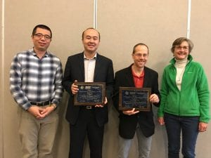
Huan Tan received the “Technological Innovation Award” for outstanding and continuous contributions to innovation and leadership in creating service robotic systems significantly impacting the industry in various domains.
John Yagielski received the “Enhancement of the Relationship Between IEEE and Industry Award” for longstanding and significant contributions to technical committee activities, standards and guides representing the electric power industry.

