Officers/Societies  CHAIR  Kelly Robinson  VICE-CHAIR  Emmett Ientilucci  TREASURER  Lyle Tague  SECRETARY  Eric Zeise  AES & COMSOC  Cristiano Tapparello  CS & CIS  Bo Yuan  EDS & CSS  Sean Rommel  EMBS  Cristian Linte  GRSS  Emmett Ientilucci  LIFE  Jean Kendrick  APS & MTTS  Danielle Walters  PHOTONICS  Parsian K. Mohseni  PES & IAS  Kelly Robinson  Jean Kendrick  SPS  Eric Zeise  TEMS  Paul Lee  YOUNG PROF.  Eric Brown  STUDENT CHAP.  Univ. of Rochester  Ming-Lun Lee  RIT  Jamison Heard  AWARDS  Jean Kendrick  COMMUNICATION  Christine Frayda  Howard Bussey  NEWSLETTER  Mark Schrader  PACE  Bruce Rubin  HISTORIAN  Ram Dhurjaty  CS/CIS  RES LIASON  Greg Gdowski | 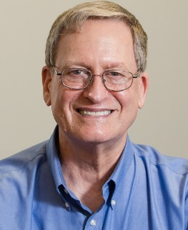  Message from the Chair  Dear Colleagues,  Our IEEE Rochester Section Women In Engineering (WIE) Affinity Group (https://wie.ieee.org/about/) hosted two significant events in October to promote talent retention within our community with a key focus on diversity and inclusion. While these vast issues may seem impossible to solve, I think of Nkosi Johnson, who fought for children with HIV/AIDS to be able to attend school. When facing this daunting challenge, this 12-year-old boy advised us to “Do all you can do with what you have, in the time you have, in the place you are.”  Let us work together to make our little corner of the world the best possible. Attend an IEEE event, learn new things, meet interesting people, support our vibrant Rochester technical community, elevate the practice of engineering, and enrich your colleagues' experiences.  NOTE: The IEEE Rochester Section Awards and Volunteer Recognition Dinner will be held on Monday, December 9, 2024, 6:00 pm – 9:00 pm at Glendoveers 2328 Old Browncroft Blvd Rochester, NY 14625  We welcome you to help us plan an interesting and exciting event. Our IEEE Rochester Section Executive Committee meets monthly to organize events. Our next meeting will be over lunch on Tuesday, December 3rd, from 12:00 PM to 1:30 pm. Please feel free to register for in-person or virtual (Zoom) attendance using this link: https://events.vtools.ieee.org/m/438307.  I look forward to working with you!  Regards,  Kelly Robinson, PE, PhD  Chair, IEEE Rochester Section  WIE - Women In Engineering Oct. 1 and Oct. 8 Events Report  This is a report from Deyasini Majumdar, Ph.D., SMIEEE, Chair, Women In Engineering, IEEE Rochester Section, 2023-2024, and Co-Chair, Program Committee, IEEE WIE International Leadership Conference 2025.  WIE Rochester held a two-event series titled 'Industry-Academia Interfaces: A Next-Gen View' on October 1 and October 8 at RIT and U of Rochester, respectively. Each event had 45+ attendees. The programs included a welcome by the engineering schools’ deans, technical talks, panel discussions, and industry exhibits. The discussions were engaging, and the feedback highlighted the local community's need to engage industry and academia.
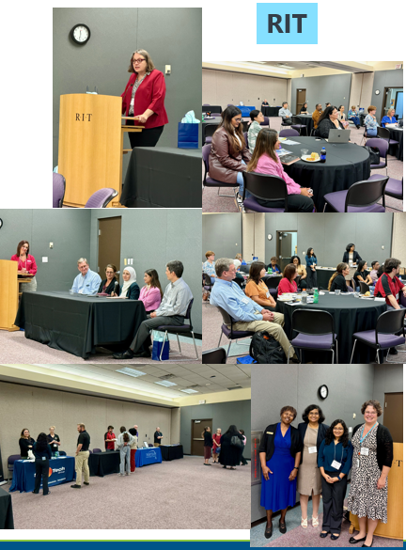
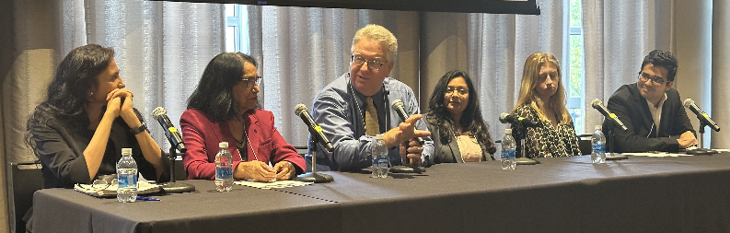

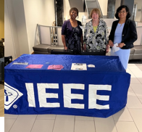
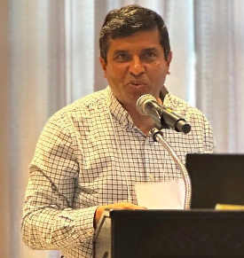

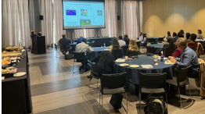

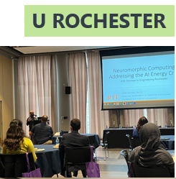



2024 Western New York Image and Signal Processing Workshop (WNYISPW)
Friday, November 8 at RIT

WNYISPW is a premiere venue for promoting research involving AI, image, and signal processing applications in the Western New York region and facilitating interaction between academic researchers, industry professionals, and students.

Registration information: https://events.vtools.ieee.org/m/426283
For further information, including the detailed program agenda, please go to the 2024 IEEE WNYISPW website: https://ewh.ieee.org/r1/rochester/sp/WNYISPW2024.html

IEEE Region R1R2 Historian and Former Section Chair Gives Keynote Address

Ram (Sreeram) Dhurjaty, PhD, LSMIEEE, R1R2 Historian, presented the keynote address at the MIT Undergraduate Research Conference on October 12 in Cambridge, MA; the title of his talk was “Past Innovations Have Influenced the Present and How Today’s Innovations Will Influence the Future.” Earlier in October, Ram presented “Radio Frequency Alternators of the 1900s” at the Antique Wireless Association (AWA) Annual Conference in Rochester, NY.

